Answer the questions about the text.

Match the words to the pictures.
crane
motorbike
car
lorry

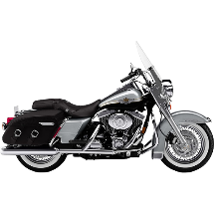
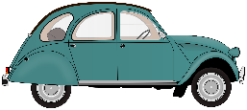

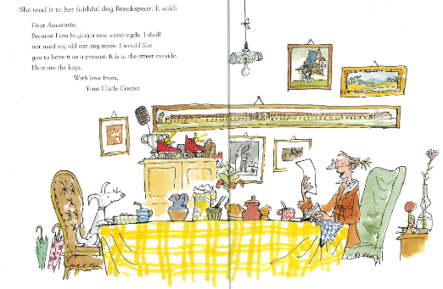

Who gave Mrs Armitage a car?
_____________________________________________________________
_____________________________________________________________

Where did Mrs Armitage take the hubcaps?
_____________________________________________________________

Write the noise the car made each time part of it fell off.
Part fallen off | Noise the car made
headcaps
mudguard
bonnet
roof

Who are Uncle Cosmo’s friends?
____________________________________________________________________________________________________________________________________________

Order the events of the story. Write numbers in the boxes. One has been done for you.
Mrs Armitage went for a drive in her car with her dog.
Mrs Armitage went to Crazy Duck Café.
Mrs Armitage got a letter off Uncle Cosmos. | 1
Mrs Armitage’s car turned into a machine.

Answers
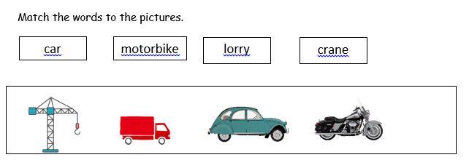
2. Uncle Cosmo gave Mrs Armitage a car.
3.
Part fallen off | Noise the car made
headcaps | Bing bong dang boing
mudguard | scrrunch
bonnet | skerrunch
roof | Kerrunch

4. Gizzy, Lulu, Ferdinando and Smudge.
5.
Mrs Armitage went for a drive in her car with her dog. | 2
Mrs Armitage went to Crazy Duck Café. | 4
Mrs Armitage got a letter off Uncle Cosmos. | 1
Mrs Armitage’s car turned into a machine. | 3

