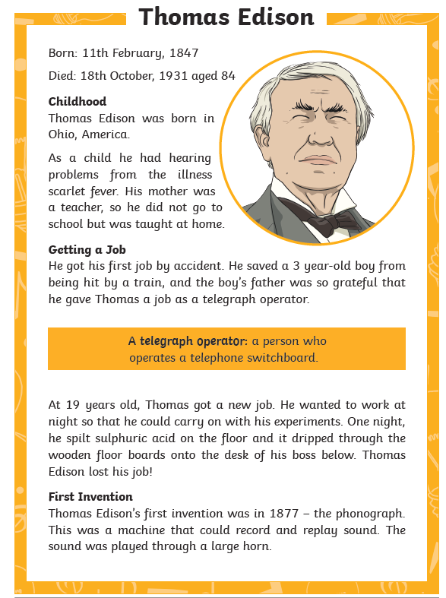
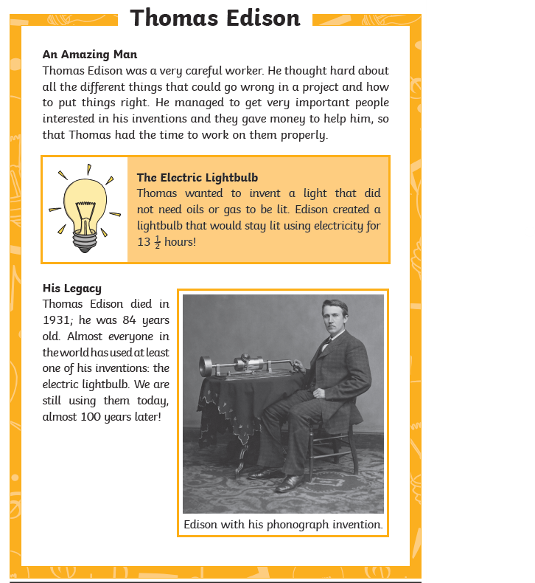
L.O. To retrieve information from a non-fiction text.

- Why did Thomas Edison have hearing problems?

- How did he get his first job as a telegraph operator?

- How did his boss find out he was doing experiments while at work?

- What was the name of the invention that could record sound?

- What did his Electric lightbulb not need to work, that other previous lights did?

- Name one quality in his character that made him a great inventor?

- How old was Thomas Edison when he died?

- Why should we be grateful to Thomas Edison?

