Year 1 Home Learning
Summer Term Week 10
Phonics  Revise all set 2 and 3 sounds using the following link.  https://www.youtube.com/watch?v=WnusnM_6R2A  Revise all sounds in your phonic booklet.  - What each sound is  - Read the words for each sound  - Get an adult to give you a spelling test of words from different sounds.  Complete this activity daily to ensure you are confident with all the sounds to improve you reading and spelling.  Mrs Flint’s group read the book ‘Our House’ every day as your home reader. (see English folder)  Mrs Badland’s Group read the book ‘Tim and Tom’ every day as your home reader. (see English folder) | Maths  Look in the Maths folder for activities. Open up the home learning video links in the maths folder to access the video starters.  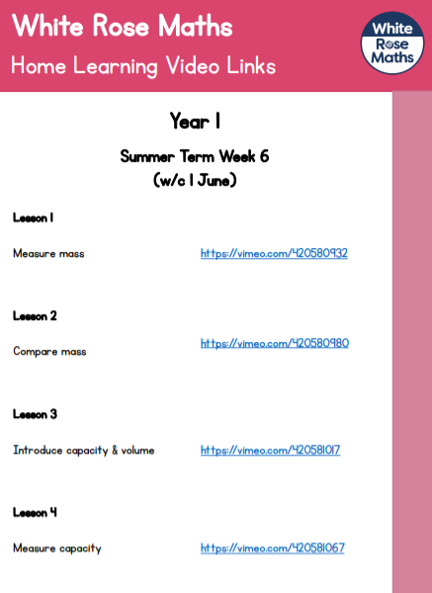
English  Read the text ‘At the Beach’ using the PowerPoint in the English folder.  - Nouns and verbs activity.  - Write a sentence about what the family are doing in each picture.  - Look at the structure of a postcard.  - Write your own postcard.  Open English activities in the English folder for more detail. You do not need to print the sheets you can write on paper. | History  Look at the seaside throughout the years using the PowerPoint presentation and discuss what you see with an adult. How has it changed? What is similar?  Then read the information about seasides and answer the questions.
Science  Listen to the Seasonal Change song using the following link;  https://www.youtube.com/watch?v=pjRDuoWJwE0  Answer the questions about Seasonal change using the song. The words for the song is in the science folder.  All resources are in the science folder. | Religious Education  Look at the presentation about being a disciple and learn about the work CAFOD do for people around the world.  Activity 1 – Make a poster CAFOD explaining who they are and what they do.  Activity 2 – Write a prayer about our family around the world.
Art  Last week you read the book, ‘The Snail and the Whale’ by Julia Donaldson. For art this week follow the step by step instructions to draw your own whale picture. (See Art Folder)  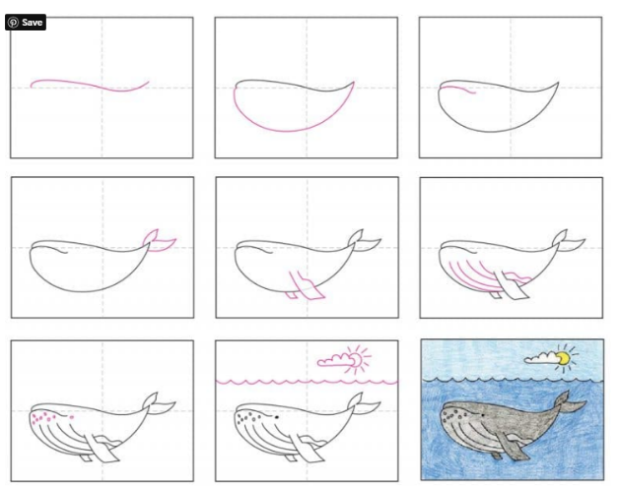 | Reading  Go onto the link:  https://www.oxfordowl.co.uk/for-home/find-a-book/library-page/?view=image&query=&type=book&age_group=Age+4-5&level=&level_select=&book_type=&series=#  and choose a book to read.
Purple Mash
Look at your Purple Mash account and have a go at the some of the activities online.

Any of your work can be attached to Purple Mash and sent to your teachers.

