Sponsor name | Amount sponsored | Money collected
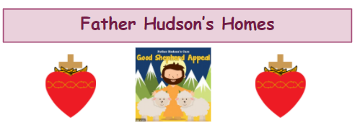
Please encourage your child to colour as many crosses as they can to raise money for this wonderful charity as part of our almsgiving during Lent.
https://youtu.be/UjY9ocfMYgw
You could sponsor your child for each cross they colour or by completing the whole 40 – or even more! Please ask friends and family for sponsorship.
Ask your child to colour their crosses on the jamboard on Google Classroom.

Sponsor name | Amount sponsored | Money collected

Thank you for your support or generosity.

