25th June 2021
Dear Parents,
In this Sunday’s Gospel, we read about how a woman’s faith was greatly rewarded. Jesus revealed the wonderful and extraordinary power he had received from his Father, by healing this woman in a remarkable way. Putting our faith in Jesus helps us to know God as our loving Father. Pope Francis reminds us, “To live by faith means to put our lives in the hands of God, especially in our most difficult moments.”
“Lord, open my heart, mind and ears to receive your Word.”
When Jesus had crossed in the boat to the other side of the lake, a large crowd gathered round him and he stayed by the lakeside. A woman, who had suffered from a haemorrhage for twelve years, came up behind Jesus and touched his cloak. “If I can touch even his clothes,” she had told herself, “I shall be well again.” And the source of her bleeding dried up instantly and she felt in herself that she was cured. Immediately aware that power had gone out from him, Jesus turned round and said, “Who touched me?” Then the woman came forward frightened and trembling because she knew what had happened to her, and she fell at his feet and told him the whole truth. “My daughter,” he said, “your faith has restored you to health; go in peace and be free from your complaint.”
Adapted from Mark 4:35-41 The 12th Sunday of Ordinary Time
“How beautiful it is to support each other in the wonderful adventure of faith!”
Pope Francis

The Wednesday words is
Faith
Feast of St Peter and St Paul
Year 2 and Year 3 will be walking to Sacred Heart Church on Tuesday to celebrate this important feast day. Please can you ensure that your child is on time for school, has appropriate footwear and a waterproof coat.
St. Peter and St. Paul is an important day in the Church year and, in normal times, is a Holy Day of Obligation. Both of them had important roles of leading the Church in its early days. St. Peter, one of the twelve apostles, was chosen by Jesus to lead the early Church. St. Paul never actually met Jesus. However, following his dramatic conversion on the road to Damascus, he spent his life preaching the Good News in many places.

Thank you
A special thank you to the pupils at St Joseph’s in Sutton Coldfield for the beautiful cards they sent the children at Sacred Heart to celebrate our feast day. It was lovely to know we were all in your prayers.

Vacant places for September 2021 FY
We currently have some vacancies in our EYFS class for September 2021 if any families are looking for places for their children. As a faith based school, we welcome children of all faiths so please spread the word so children do not miss out. Contact the school office on 356 4721 to enquire or by email enquiry@sacredheart-sch.net.
We currently have some vacancies in EYFS, Years 1, 3 and 4.

Transition Days
Due to the extension of the Covid 19 restrictions, Birmingham secondary schools have cancelled the Year 6 transition days. Miss Latchman and Miss Joseph will work with the Year 6 children as best as they can to compensate for this and support pupils in journey on from Sacred Heart.
On 19th July, all pupils in school will have their own moving up day when they will get the opportunity to spend the day with their new teaching staff. During this time, Year 6 will have the opportunity to take part in sports, team building and transition activities with Mr Miller and other adults.

Warm weather
We have been blessed with some lovely warm weather over recent weeks. If your child requires suncream, please apply this before they come to school. It is important that children all have a water bottle with them each day and possibly a sunhat.

Ordering new school Uniform
Please remember that school uniform can be ordered from the link on our school website for the Summer term. We fully understand that some children have suddenly grown out of some uniform items and shoes but it is essential that the correct uniform is purchased in time for the first day back in September- Friday 3rd September.
https://www.sacredheart-sch.net/website/school_uniform/5938

Term Dates for next Academic Year 2021-2022
Autumn Term 2021:
Term starts: Thursday 2 September 2021-
2nd September is a school Inset day- pupils return on Friday 3rd September.
Half Term: Monday 25 October 2021 to Friday 29 October 2021
Term ends: Friday 17 December 2021
Spring Term 2022:
Term starts: Tuesday 4 January 2022
Half Term: Monday 21 February 2022 - Friday 25 February 2022
Term ends: Friday 8 April 2022
Summer Term 2022:
Term starts: Monday 25 April 2022
Half Term: Monday 30 May 2022 to Friday 3 June 2022
Term ends: Friday 22 July 2022
Other Inset days are yet to be confirmed

On Monday, all of the children in school celebrated ‘World Music Day.’ In 1981, Maurice Fleuret, a French composer, became the Director for Music for the French Ministry of Culture. He had a strong belief that music should be everywhere and available to everyone. This is where the special event grew from. The children had a wonderful time listening, responding, appraising and playing music. It was lovely for the children to have the opportunity to express themselves and gain an understanding about a variety of musicians and composers.
Thank you to Mrs McGrory for organising this day.
In FY, the pupils celebrated World Music Day by focusing on the composer Gustav Holst and listening to parts of his orchestral suite ‘The Planets’. They recognised instruments they could hear and discussed what they liked and disliked about the music. The children enjoyed playing some percussion instruments while listening to ‘The Planets.’

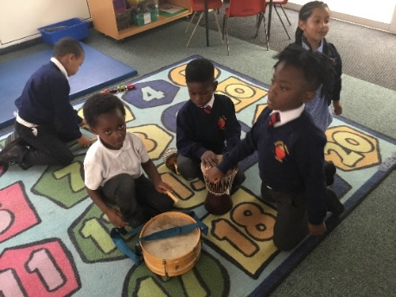
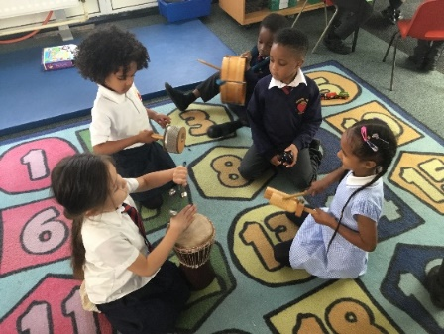

To celebrate World Music Day, Year 1 learned all about Maurice Ravel. The children found out facts about Maurice Ravel. They then listened to his famous ‘Bolero’ piece of music being played by an orchestra and discussed the different instruments being played. The children then found out about Torvill and Dean and how they used this piece of music to create an ice skating sequence, which won them a gold medal at the Olympics in 1984. They then created the bassline for the piece of music and the rhythm. Children used instruments to follow the rhythm and some children became the composer; keeping the children in time.

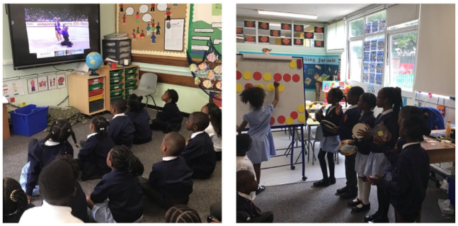

Year 2 found out about the life and music of Tchaikovsky. They also learned about the story of the Nutcracker and enjoyed waltzing and pirouetting to The Dance of the Flowers and the Dance of the Sugar Plum Fairy. The children responded to how the music made them feel, discussed the pictures in their minds and the colours they imagined. Some children chose to retell the story of The Nutcracker.
Some children were able to link this learning to their reading books ‘Meet a Genius’ and ‘Meeting Mozart.’

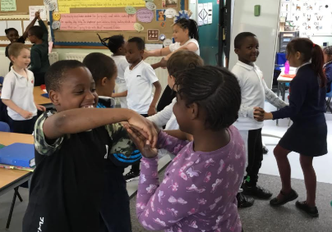
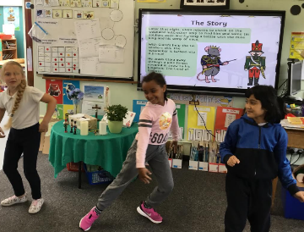
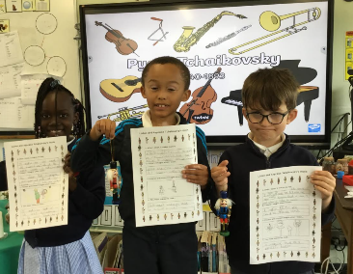

Year 3 listened to the horn concerto by Haydn and explored his life and learned about when he composed his music. Inspired by the concerto, they composed their own tunes using words first and then adding musical notation.

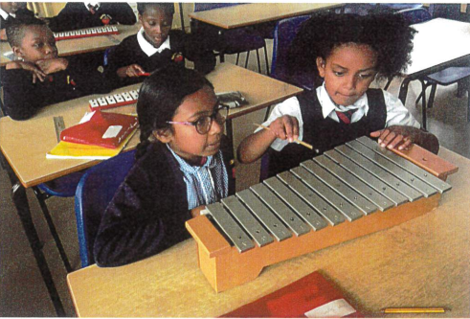
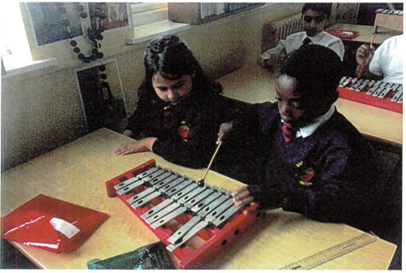
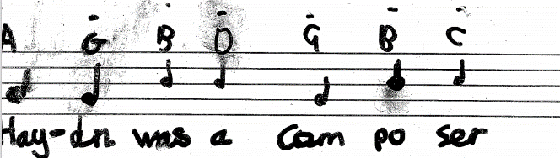

Year 5 enjoyed researching the famous German composer
Ludwig Van Beethoven using the internet and then wrote a biography of his life and his musical achievements using a template on Purple Mash. These are the children’s wonderful pencil portraits.

Engagement in Learning
FY have been very excited this week as the caterpillars that they have been looking after have eventually turned into beautiful butterflies. From looking at the wonderful photos, we are not sure who was more excited; Mrs Whitty or FY!
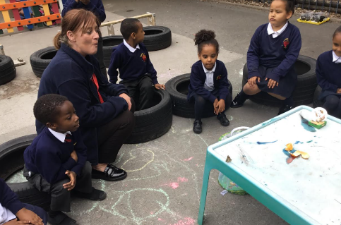
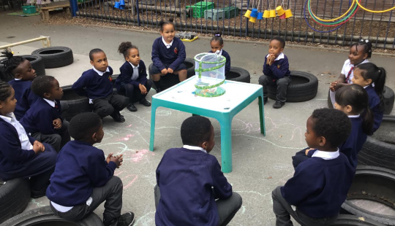

Gospel Virtues
This half term, the children are learning to be faith-filled and hopeful. Pupils will be growing to be faith-filled in their beliefs and hopeful for the future.
Congratulations to the following children for living out these virtues: Elime, Emarna, Javier, David, Prince, Naphtali and Elijah.

Commendations
The following children have been commended by their teachers and teaching assistants for their wonderful work in school: Emmanuel, Abigail, Sarina, Nelson, Eesa, Lois and Troy.

Presentation Awards
Well done to the following children who have shown such pride in the presentation of their work this week. Eliyannah, Mercy, Anayah, Nicole, C’Asia, Chiemena and Amir.

Extra Curricular activities awards
Congratulations to Mathius, Malaki and Malika for their amazing achievements at boccia. Miss Joseph was very proud of you!
Khalia Mai in Year 1 received the trophy for amazing work in gymnastics and David from Year 3 has been praised for his wonderful sportmanship in athletics. -

Special mention Postcards
Congratulations to Archie, Khalisa-Mai and Heyab who all received a postcard home from Mrs Elliott for amazing work in class.

House Points
Congratulations to St Luke for being the winning house this week.

Attendance
FY | Year 1 | Year 2 | Year 3 | Year 4 | Year 5 | Year 6 | whole school
92.53% | 100% | 89.29% | 94.58% | 97.6% | 98.96% | 97.6% | 95.82%
Congratulations to Year 1 who won this week’s attendance award. Well done, children for knowing that every day matters.

June is the month of
The Sacred Heart of Jesus
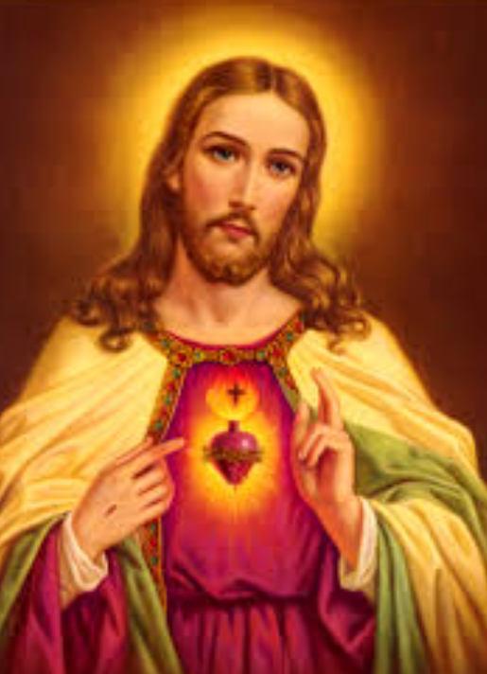
O Sacred Heart of Jesus,
I place all my trust in you.

Yours sincerely
Mrs G Elliott
Acting Head of School
Mrs D Cooper
Acting Vice Principal
Mr G M O’Hara
Executive Principal

