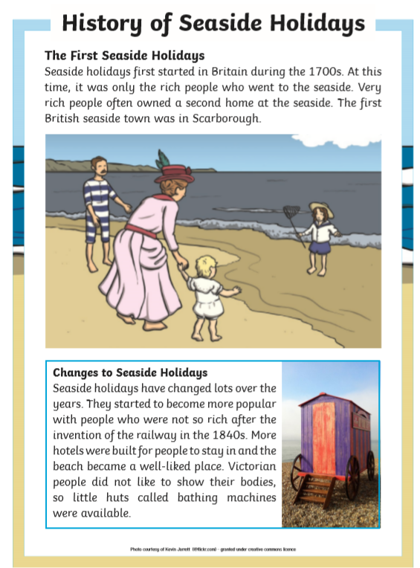

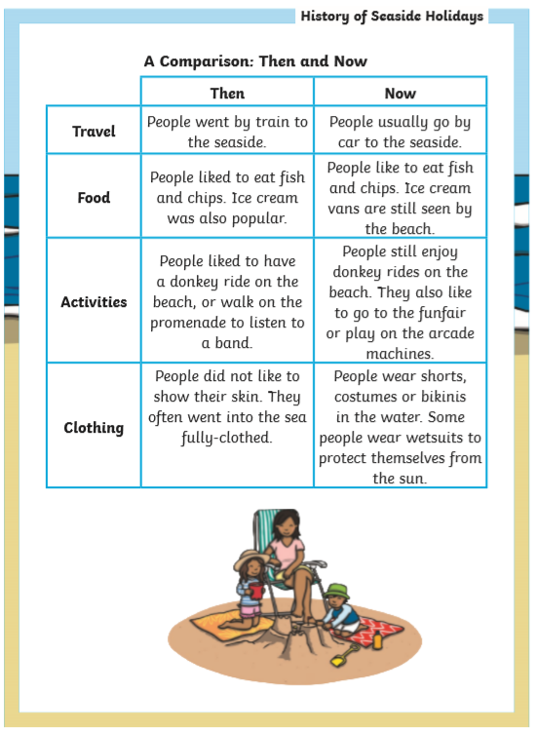

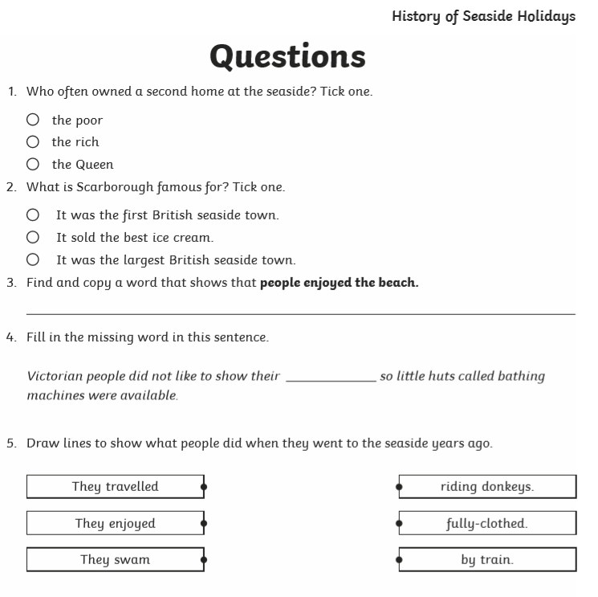

6. How do people travel to the seaside now and in the past?

|  |  |
| --- | --- |
| Then |  |
| Now |  |

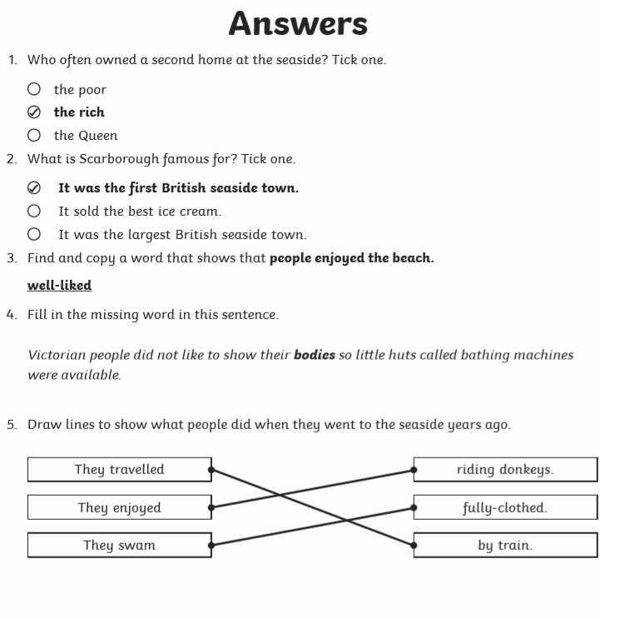

6. How do people travel to the seaside now and in the past?

|  |  |
| --- | --- |
| Then | By train |
| Now | By car |