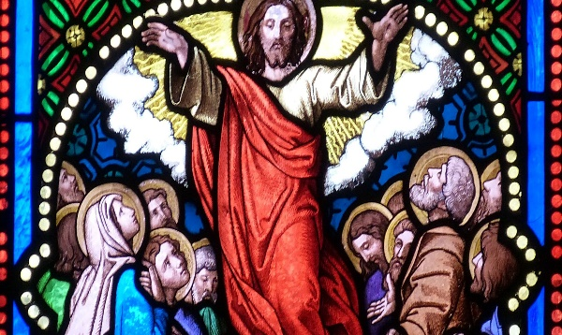
LO – To know about and discuss the Ascension of Jesus.

Read the story of the Ascension of Jesus from The Acts of the Apostles

From reading this story, why do you think Jesus had to return to God his Father?
__________________________________________________________________________________________________________________________________________________________________________________________________________________________________________________________________________________________________________________________________________________________________

Do you think that the apostles were sad to see Jesus return to the Father?
__________________________________________________________________________________________________________________________________________________________________________________________________________________________________________________________________________________________________________________________________________________________________

From the words of the text, what do you think might have helped them to overcome their sadness?
__________________________________________________________________________________________________________________________________________________________________________________________________________________________________________________________________________________________________________________________________________________________________

Write a diary entry as one of the apostles witnessing the Ascension of Jesus
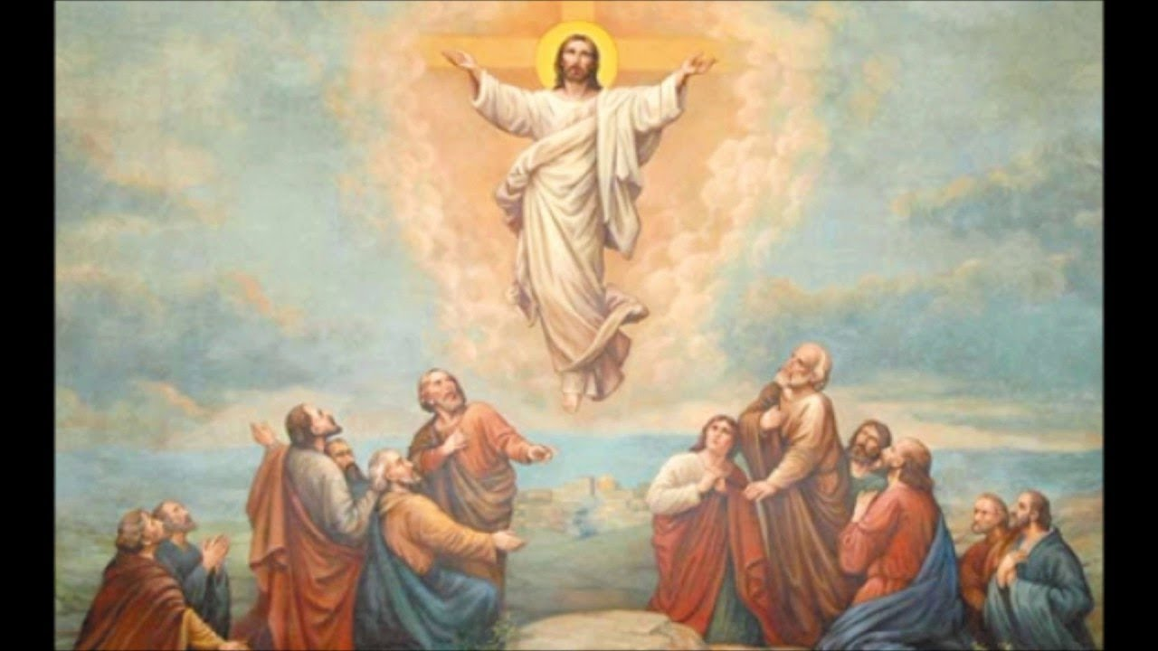
into heaven.
____________________________________________________________________________________________________________________________________________________________________________________________________________________________________________________________________________________________________________________________________________________________________________________________________________________________________________________________________________________________________________________________________________________________________________________________________________________________________________________________________________________________________________________________________________________________________________________________________________________________________________________________________________________________________________________________________________________________________________________________________________________________________________________________________________________________________________________________________________________________________________________________________________________________________
____________________________________________________________________________________________________________________________________________________________________________________________________________________________________________________________________________________________________________________________________________________________________________________________________________________________________________________________________________________________________

Design a stained glass window of the Ascension

