What to do today
IMPORTANT Parent or Carer – Read this page with your child and check that you are happy with what they have to do and any weblinks or use of internet.

1. Make predictions about a story
- Look at the Front Cover of Mufaro’s Beautiful Daughters.
- Make a note of all the things that you can notice. Who do you think the people are? Why is there a mountain? Who is the picture of?
- What do you think might happen in this story?

2. Read the start of the story and answer questions
- Read Mufaro Beginning.
- Answer Mufaro Questions 1.
- Challenge yourself to answer Mufaro Questions 2.

Well done! Share your answers with a grown-up. Show them what you have read and where you found the answers. You can check your answers to Mufaro Questions 1 at the end of this document.

3. Character Outlines
- Use Three Outlines. Write notes to explain what you know and think about Mufaro, Manyara and Nyasha.

Try the Fun-Time Extra
- Use Three Outlines to make notes about three people that you know. What do you know about them? What do you think that you know about them?

Front Cover

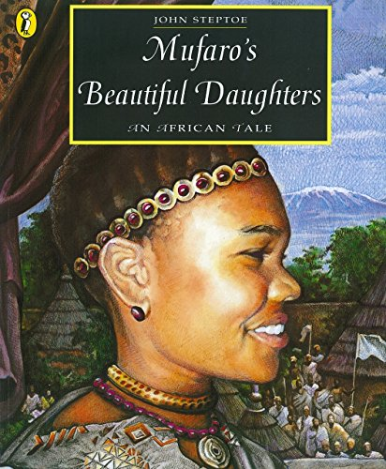

Mufaro Beginning

A long time ago, in a certain place in Africa, a small village lay across a river and half a day’s journey from a city where a great king lived. A man named Mufaro lived in this village with his two daughters, who were called Manyara and Nyasha. Everyone agreed that Manyara and Nyasha were very beautiful.

Manyara was almost always in a bad temper. She teased her sister whenever their father’s back was turned, and she had been heard to say, “Someday, Nyasha, I will be a queen, and you will be a servant in my household.”
“If that should come to pass,” Nyasha responded, “I will be pleased to serve you. But why do you say such things? You are clever and strong and beautiful. Why are you so unhappy?”

“Because everyone talks about how kind you are, and they praise everything you do,” Manyara replied. “I’m certain that Father loves you best. But when I am a queen, everyone will know that your silly kindness is only weakness.”

Nyasha was sad that Manyara felt this way, but she ignored her sister’s words and went about her chores. Nyasha kept a small plot of land, on which she grew millet, sunflowers, yams, and vegetables. She always sang as she worked, and some said it was her singing that made her crops more bountiful than anyone else’s.

One day, Nyasha noticed a small garden snake resting beneath a yam vine. “Good day, little Nyoka,” she called to him. “You are welcome here. You will keep away any creatures who might spoil my vegetables.” She bent forward, gave the little snake a loving pat on the head, and then returned to her world.

From that day on, Nyoka was always at Nyasha’s side when she tended her garden. It was said that she sang all the more sweetly when he was there.

Mufaro knew nothing of how Manyara treated Nyasha. Nyasha was too considerate of her father’s feelings to complain, and Manyara was always careful to behave herself when Mufaro was around.
From John Steptoe: Mufaro’s Beautiful Daughters

Mufaro Questions 1

1. How long would it take to journey from the village to the city?

2. What was special about Mufaro’s daughters?

3. What did Mufaro do to her sister?

4. How did Nyasha respond to her?

5. What did Nyasha grow?

6. Why did people say that her crops grew so well?

7. What did Nyasha spot underneath a yam vine?

8. Why did she decide to be kind to the snake?

9. What name did she give it?

10. Why didn’t Mufaro do anything about the way that Manyara treated Nyasha?

Mufaro Questions 2

1. What does Manyara say to Nyasha? What is Nyasha’s response? Does it surprise you? Why/Why Not?

2. How does Manyara explain her bad temper? Do you agree with her explanation? Why/Why Not?

3. Do you agree with Nyasha that Manyara is unhappy? Is it always true that people who are unkind are unhappy?

4. Why do you think that Nyasha spends her time growing plants and vegetables?

5. What would be another way of saying that her crops were bountiful?

6. Are you surprised at the way Nyasha responds to the snake? Why/Why Not?

7. Why do you think the writer uses the phrases: ‘some said it was her singing…’ and ‘It was said that she sang …’

8. Why doesn’t Nyasha tell her father about Manyara? Is she right to stay quiet? Why/Why Not?

Three Outlines

Mufaro Questions 1 – Possible Answers

1. How long would it take to journey from the village to the city?
Half a day.
2. What was special about Mufaro’s daughters?
They were beautiful.
3. What did Mufaro do to her sister?
She teased her.
4. How did Nyasha respond to her?
She was gentle.
5. What did Nyasha grow?
Millet, sunflowers, yams and vegetables.
6. Why did people say that her crops grew so well?
Because of her singing.
7. What did Nyasha spot underneath a yam vine?
A small garden snake.
8. Why did she decide to be kind to the snake?
It would keep away creatures that might spoil the plants.
9. What name did she give it?
Nyoka
10. Why didn’t Mufaro do anything about the way that Manyara treated Nyasha?
She didn’t want to upset her father.

