Year 1 Home Learning
Summer Term Week 11
Phonics  Revise all set 2 and 3 sounds using the following link.  https://www.youtube.com/watch?v=WnusnM_6R2A  Revise all sounds in your phonic booklet.  - What each sound is  - Read the words for each sound  - Get an adult to give you a spelling test of words from different sounds.  Complete this activity daily to ensure you are confident with all the sounds to improve you reading and spelling.  Mrs Flint’s group read the book ‘A Box Full of Light’ every day as your home reader. (see English folder)  Mrs Badland’s Group read the book ‘Tag’ every day as your home reader. (see English folder) | Maths  Look in the Maths folder for activities. Open up the home learning video links in the maths folder to access the video starters.  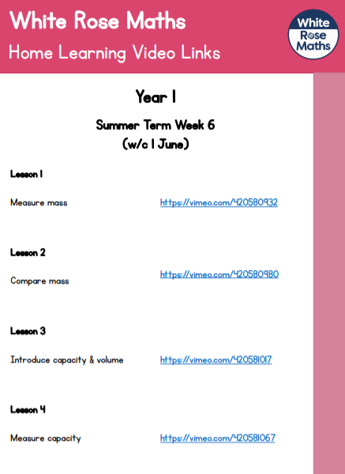
English  Read the text ‘Mrs Armitage Queen of the Road’ using the PowerPoint in the English folder.  - Use the pictures to write how Mrs Armitage’s car turned into the machine everyone loves.  - Answer questions about the text.  - Look at the pictures and write what the characters might be thinking.  - Answer the inference questions.  Open English activities in the English folder for more detail. You do not need to print the sheets you can write on paper. | Geography  We have spent the past four weeks learning about the seaside. Use what you have learnt to label the features of a seaside town.
Science  Science experiment 1 – make a rain gauge  Science experiment 2 – make a windsock  See instruction in the science folder.  When you have made a windsock and a rain gauge you can place them outside and become a weather watcher like Wilbur. | Religious Education  We are thinking about the life of Jesus this week. Jesus did so many things and changed so many lives when he was on earth.  Activity 1  Look at the images and see how many of the stories you can name from Jesus’ life.  Activity 2  Complete the ‘favourites’ sheet about the life of Jesus.
Art  Follow the instructions in the art folder to make a paper fish.  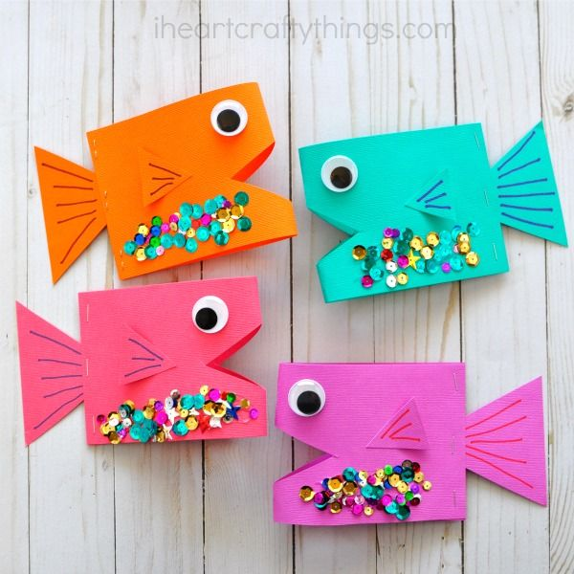 | Reading  Go onto the link:  https://www.oxfordowl.co.uk/for-home/find-a-book/library-page/?view=image&query=&type=book&age_group=Age+4-5&level=&level_select=&book_type=&series=#  and choose a book to read.
Purple Mash
Look at your Purple Mash account and have a go at the some of the activities online.

Any of your work can be attached to Purple Mash and sent to your teachers.

