13th March 2020

Dear Parents,

**Sacrament of Reconciliation**

At 9.00am at Sacred Heart Church this Sunday, children from Year 3 and Year 4 will be celebrating the Sacrament of Reconciliation for the first time. During this special Sacrament, the children confess their sins and receive God’s forgiveness; they are reconciled with God. This is also a day of prayer for the candidates of Sacraments so please keep these children in your prayers.

*Chidera Afoka-Obieshi Injacio Mjeda Clarissa Oledibe Michael Osagie Malonga, Valery Osagie Osamudamen Josiah Rodriguez Helena Tesfay James Ajayi*

**Irish Week – Monday 16th March**

We are very fortunate to have a huge variety of cultures at Sacred Heart and we celebrate as many of these as possible through our cultural weeks. Next week is Irish Week so children will be celebrating the feast of St Patrick through enrichment activities in class and our traditional Talent show on Friday.

Children can wear their own clothes or something green on this day by donating 50 pence to CAFOD.

**CAFOD Fundraising**

During Lent we will be holding a number of fundraising activities to raise money for CAFOD. Your child will have been provided with a collection box in which they can collect any spare change for CAFOD during Lent. We will collect these in during the last week of term. Other activities organised by Mr Miller, Miss Weston and the School Council are:

* Non Uniform day Friday 20th March 50p
* ‘Teachers vs Kids’ dodgeball Throughout Lent 20p
* Easter Egg raffles Throughout Lent 20p
* Guess the eggs in the jar Throughout Lent 20p



Thank you to the 89% of parents who have signed up for the Parent mail system. It is a great way to receive up to date information about school and to be kept informed of events. We only have 21% of parents who have downloaded the app on their phones. This is free and would be an easy way for you to receive immediate messages from school so children do not miss out on opportunities. The app can be downloaded from the app store on all mobile phones.

**Parking outside school reminder**

For the safety of your children, please do not park on the zig zags outside of school or move the parking signs at any time of the day. Thank you.

**Punctuality Matters**

*Missed minutes = missed learning = missed opportunities!*

Being on time for school is extremely important. We have a number of children who are arriving late which has a negative impact on their learning. If parents find themselves running behind in the mornings, please consider some of these ideas for improving punctuality.

**Bedtime routines** – packing school bags ready for the next day, getting to bed earlier, setting a time for a televisions, IPads, computers, mobile phones and other devices to be turned off.

**Morning routines** – setting the alarm earlier, no television until ready for school (and maybe not even then), having breakfast before leaving home, so no need to call in at the shop, meeting a reliable friend to walk to school with.

|  |  |  |  |
| --- | --- | --- | --- |
| **Missing just…** | **That equals…** | **Which is…** | **Over 13 years of schooling that is…** |
| 10 minutes a day | 50 minutes per week | Nearly 1 ½ weeks per year | Nearly ½ a year |
| 20 minutes a day | 1 hour 40 minutes per week | Over 2 ½ weeks per year | Nearly 1 year |
| 30 minutes a day | Half a day per week | 4 weeks per year | Nearly 1 ½ years |
| I hour | 1 day per week | 8 weeks per year | Over 2 ½ years |

If your child is late 10 minutes a day…this is how it affects their schooling.

Where punctuality has become a concern, parents will be spoken to at parent’s evening. We can then discuss how we can support you to help improve your child’s attendance and to help them to succeed at school.

**Coronavirus**

We are continuing to monitor the ongoing situation and we are following all Public Health England and Government guidelines. Parents will be notified immediately if we have any concerns in school or receive advice from the PHE. The school website is being regularly updated with information under the ‘Information for parents’ section. Please use the following link:

<https://www.sacredheart-sch.net/website/coronavirus_advice_for_parents/455467>

The most important action you can take is to ensure that all families are washing their hands thoroughly for 20 seconds with soap and warm water as often as possible. Drinking water regularly will also help.

**If you or your child has a new and continuous cough or a fever please stay at home.**

**Contact school immediately if your child is unwell.**

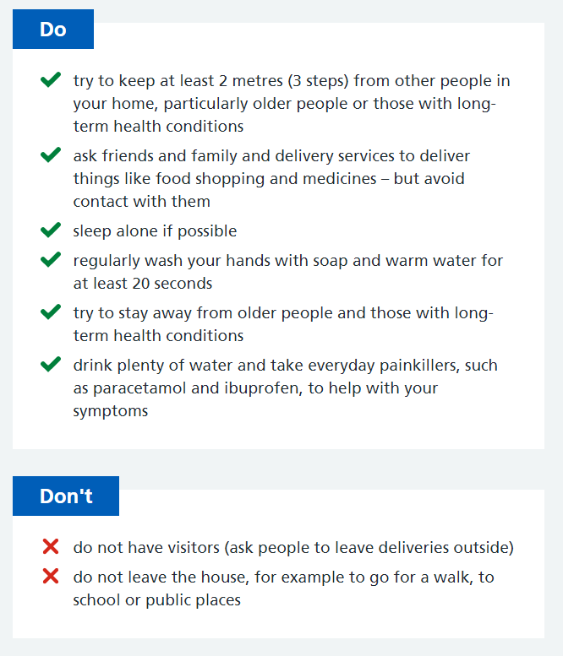

**Dates for your diary**

Irish Week Monday 16th March

Alton Castle Retreat Thursday 19th March

Parent’s Evening Tuesday 24th March

Year 5 ‘Born for This’ assembly Wednesday 8th April 10.30am

**Gifts from God**

Please log into our school website for photographs of all of our wonderful children whose Gifts from God have been celebrated recently.

**Congratulations**

**House Points**

The winning house this week was St Luke. Please make sure your child wears their house saint badge with pride.

**Commendations**

Well done to the following children: Vhenice Lawrence, All of Year 1, Zabreena Archer-Keown, Valery Osagie Osamudamen, All of Year 4, Meliyah Scott and Milcah Yosef.

**Presentation award:** Chiamaka Medukam, Chika Opara, Nelson Minja, Injacio Mjeda, Julia Okunbor, Milan Byfield and Kah’vanni Lincoln

**Gospel Virtues:**

This week the following children have displayed their wonderful virtues:

Aaron Adjeji, Henon Yodef, Nicole- Raisa-Mihai, Chidera Afoka-Obieshi, Kevin Sledz, Frank Abangbee and Chidubem Afoka.

This half term, we fill be helping the children to be faith-filled and hopeful. Pupils will be growing to be **faith-filled** in their beliefs and **hopeful** for the future.

Year 1 performed a beautiful assembly teaching us all how to be faith-filled and hopeful on Wednesday. Thank you to Mrs Flint and Mrs Badland in preparing the children.

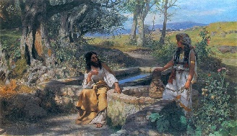

“Lord, open my heart, mind and ears to receive your Word.”

In this Sunday’s Gospel, Jesus is thirsty and so he asks a Samaritan woman for a drink from the well. The woman is surprised because normally Jews and Samaritans did not get along. It was also unusual at the time for a man to talk to a woman he did not know. But even though it is unusual, Jesus talks to the woman anyway. Jesus is showing us that God loves everyone. Jesus shows the woman that he is Christ, the Son of God, by knowing all about her life even though he has never met her before. How do you think this makes the woman feel? God wants us to love and care for all people no matter who they are because we are all part of one global family. God wants us to help each other when things are difficult and to work together to make the world a better place for everyone to live in.

Wednesday’s Words are

God’s Love

*“God loves each of us as if there were only one of us to love.*”

St Augustine of Hippo

Yours sincerely



en.



Mrs G Elliott

Acting Head of School



Mrs D Cooper

Acting Vice Principal

Mr G M O’Hara

Executive Principal