Learn about the seasons with the seasonal change song by clicking the link below.
https://www.youtube.com/watch?v=pjRDuoWJwE0
Here are the lyrics:
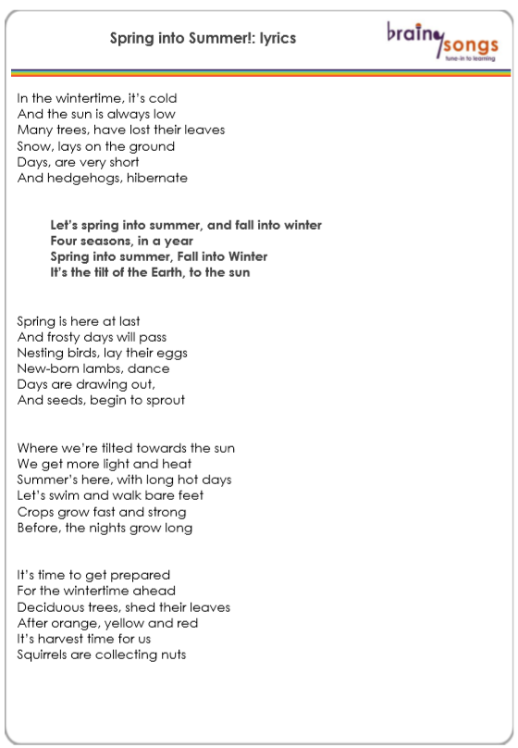

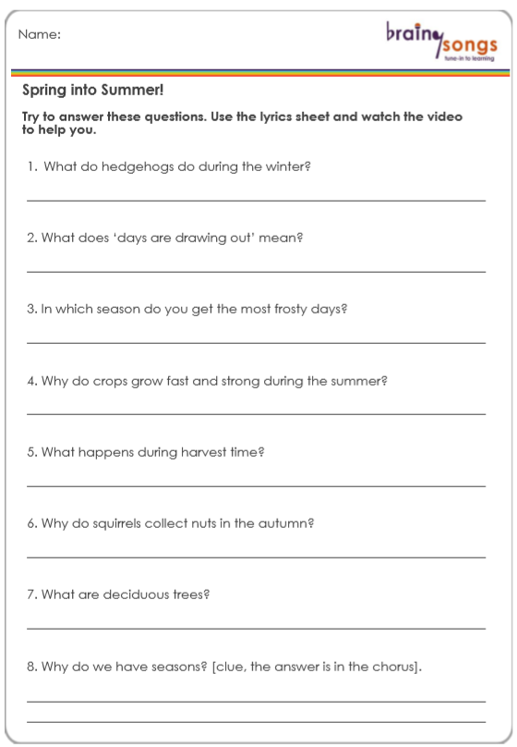
Now use the song to answer the following questions.

