Year 1 English Activities
WB 06.07.2020
Red words to learn to read and spell this week.
Small they your want where
Text – At the Beach
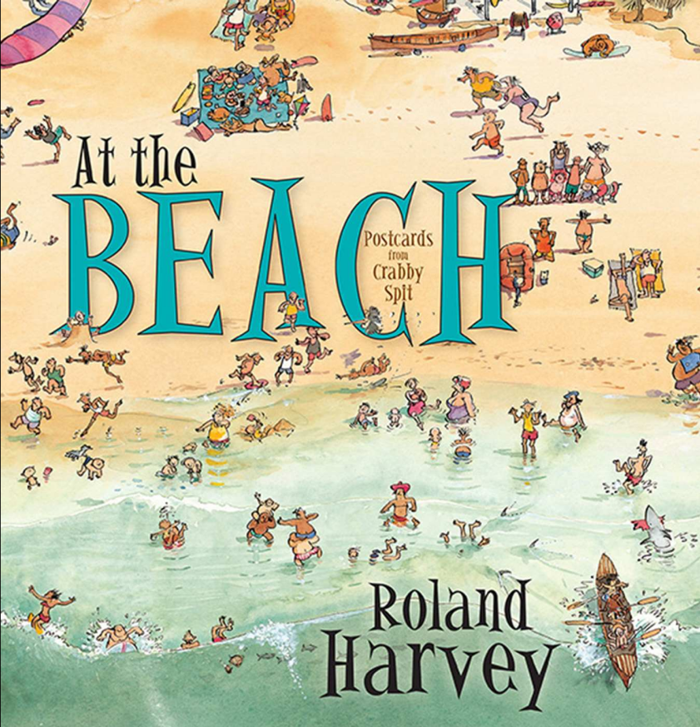
Read the text daily at the beginning of each English lesson.
Monday
After reading the text, visit the BBC website to learn about verbs using the following link.
https://www.bbc.co.uk/bitesize/topics/zrqqtfr/articles/zpd8ng8
Watch the video clip and complete the activities and quiz.
Now read the postcard on Monday’s activity and write a list of nouns in the text.
Go back to the BBC website to learn about verbs using the following link.
https://www.bbc.co.uk/bitesize/topics/zrqqtfr/articles/zpxhdxs
Re-read the postcard and write a list of all the verbs.
Tuesday
Read ‘At the Beach’
Look at the pictures from the text. What is the family doing? Write a sentence about what the family did on each day. You can use the postcards from the text to help you.
Wednesday
Read ‘At the Beach’ Look at the Postcard PowerPoint to learn how to write a postcard.
Read the example postcard on Wednesday activity. Today you are going to look at the layout of a postcard and what needs to be included.
Cut out the jumbled postcard. Using the grid showing you the layout of a postcard place the sections back together in the correct order.
For example, The first thing to include on a postcard is an informal greeting such as hi, hello. Find the part of the postcard that says Hi Grandma, and stick it into the grid.
Thursday
Write your own postcard using the writing frame. Try and stick to the traditional layout of a postcard by following the picture clues to structure your postcard. Your postcard can be about a real holiday that you have been on or it can be from your imagination.
Daily reading
In the English folder there is a home reading text for you to read every day to practise your phonics. Read the book to an adult every day.
Mrs Flint’s Group – Our House
Mrs Badland’s group – Tim and Tom

