Year 4 timetable

 | 9.00am-9.30am | Break  9.30am-9.45am | 9.45am-10.30am | Break  10.30am-10.45am | 10.45am-11.15am | 11.15am-12.00pm | Lunch  12.00pm-1.30pm | 1.30pm-2.15pm
Monday | PE  Create an obstacle course |  | Maths  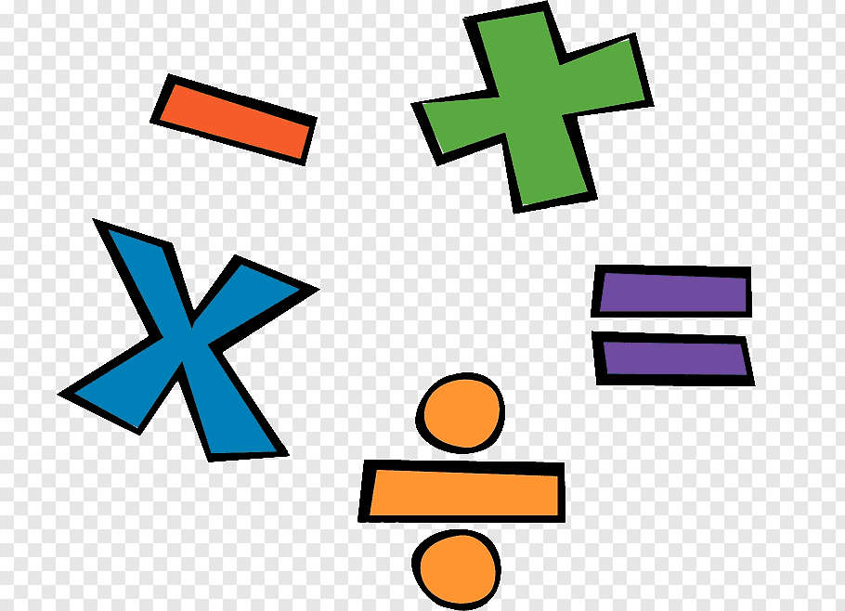 |  | English/Reading | R.E. |  | History  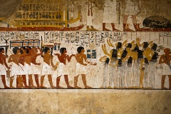
Tuesday | PE  Cosmic Yoga  (YouTube) |  | English |  | Maths | Purple Mash |  | Art
Wednesday | PE  Just Dance  (YouTube) |  | Maths |  | English | R.E. |  | Readiwriter/Spellings
Thursday | PE  Cosmic Yoga  (YouTube) |  | English |  | Maths | Purple Mash - Computing |  | Science
Friday | PE  Go Noodle – Choose ones we have done in clas.  (YouTube) |  | TTRS |  | English | R.E. |  | Mathletics/TTRS
You have been allocated set work to do each day. Print it off if you can or just use your book to note down your answers. Contact school if you need support.
Remember we need some prayers for the school website!
Please contact school if children have no access to the internet via a tablet, laptop or desktop computer. Children can contact Miss Callan through 2email on Purple Mash.

