 **Parish of the Sacred Heart and Saint Margaret Mary, Aston**

*Parish Priest:* Fr. Stephen Pimlott

Telephone (0121) 327 0235

[sacredheartaston@hotmail.com](mailto:sacredheartaston@hotmail.com)

website [www.sacredheartaston.com](http://www.sacredheartaston.com)

Safeguarding Representatives:

Sacred Heart - Teresa O’Gorman 07585907706 & Sheila McKernan 0121 344 3028

Roman Catholic Archdiocese of Birmingham - Registered Charity No. 234216

**ADVENT SUNDAY 30th November/1st December 2019**

|  |  |  |  |
| --- | --- | --- | --- |
| **Day** | **Aston** | **Nechells** | **Intention** |
| **Saturday** | **12.30 pm** | **6.00 pm** | *Peter Hanford & Ann Mann (Wedding)*  *Bob Lily & Hugh Laurie* |
| **SUNDAY** | **10.00 am** |  | *People of Parish* |
| **Monday** |  | **9.30 am** | *Robert Roddy* |
| **Tuesday** |  |  | No Mass |
| **Wednesday (school)** |  | **9.30 am** | *TBA.* Mass in St. Joseph’s school |
| **Thursday (school)** | **9.10 am** |  | *TBA* Mass in Sacred Heart school |
| **Friday** *Day of abstinence* | **9.30 am**  **10.00 am** | **11.45 am** | Exposition of the Blessed Sacrament  *Jim Maguire*  Eucharistic Service |

**ADVENT 2 Bible Sunday 7th/8th December 2019**

|  |  |  |  |
| --- | --- | --- | --- |
| **Saturday** | **12.30 pm** | **6.00 pm** | *People of Parish*  *Pat Wall* |
| **Sunday** | **10.00 am** |  | *Hekuran Halili* |

*TBA To be announced*

**Please Pray for the sick**; Mary Levell, Peter McKernan, William Parish, Julie Gallagher, Anne Robinson, Maura Greene, Jimmy Armstrong, Pat Davis, Bernadette Harnett, Lisa Brean, Michael O’Connor, Andy Walsh, Michael Brennan, Alex McClure.

The Collection last weekend came to £275.35

The second collection for the Diocesan Youth Services came to £111.05

This weekend we shall have our November **Fiver a month** collection.

Next weekend there will be a second collection for the Poor Parishes.

**ADVENT COURSE ON GLOBAL HEALING** This course will run on Wednesday evenings during Advent, 4th, 11th, 18th December at St. Vincent’s, Francis Street, Nechells. It is for the three parishes, Sacred Heart, St. Joseph’s and St. Vincent’s, but of course others can come, so bring your friends. They will start at 6.30 pm for 7 pm with light refreshments.

**THE WEDDING OF ANNE MANN & PETER HANFORD** takes place at Sacred Heart at the 12.30 pm Saturday Mass this weekend. The Mass will be the Mass for Advent Sunday.

**FIRST FRIDAY OF FAITH** is 6th December. We shall watch “The Nativity Story” to help prepare for Christmas. 6.30 pm for teas & coffee 7 pm prompt start. In the Undercroft.

Monday week, 9th December, is the **Solemnity of the Immaculate Conception of our Lady**, Patroness of our diocese and the **10th anniversary of Archbishop Bernard’s installation as our Archbishop**. You are invited to a special Mass at St. Chad’s Cathedral at 12 noon with refreshments afterwards.

You are invited to a **CAROL SERVICE** at Aston Anglican Parish Church on Thursday 5th December at 1.30 pm.

**CONFESSIONS** during Advent in preparation for Christmas. In addition to the normal Saturday time, both Fr. Stephen & Fr. Mark will be available for confessions following the Masses on Sunday15th and Sunday 22nd December.

**BECOMING A CATHOLIC** If you wish to become a Catholic, or know someone who wishes to become a Catholic, or perhaps are a Catholic but have little perception of what that means, please contact Fr. Stephen by phone, email or in person.

**ENGLISH PRAYER TIME** You are specially invited to come to the prayer time in the Undercroft on Monday nights 8 -10 pm. when everything will be in English. You can check that it is happening by phoning Sr. Meena on 0795 7342742.

**DAILY EXPOSITION** There is normally exposition in the Presbytery every day 10 am – 5 pm and 8 pm – midnight. To check phone Sr. Meena on 0795 7342742.

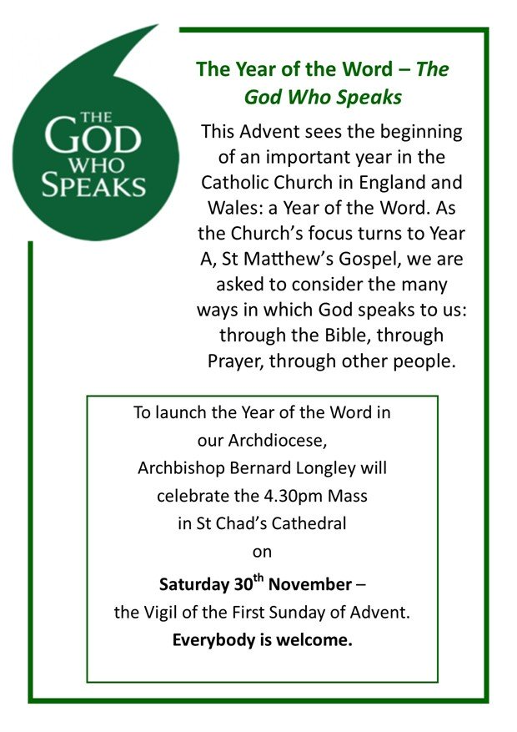**Catholic Singles** is an organisation which helps single Catholics of all ages (over 18 years) meet other single Catholics, either one to one or through social events. For further information visit www.catholicsingles.org.uk or tel. 0161 941 3498

**England, The Dowry of Mary**

There is a tradition that the title ‘Dowry of Mary’ goes back to St Edward the Confessor (1042 – 1066). There is no doubt, about the deep devotion to Our Lady that existed in medieval England, and the fame of Walsingham and other medieval English Shrines of Our Lady are a strong testimony to this devotion.

The first documentary evidence for the title was found in a painting which used to hang in the Hospice of St Thomas, which was the English Hospice for pilgrims in Rome, now the Venerable English College. It showed King Richard II (r. 1377-1399) and his consort Anne of Bohemia at Westminster Abbey on the feast of Corpus Christi in 1381. They are praying at the Shrine of Our Lady of Pewe, offering England to Our Lady as Her Dowry. He holds a parchment with a Latin inscription: ‘Dos tua pia haec est, quare leges, Maria’ – This is your dowry, O pious Virgin.

We are being asked to rededicate England as Our Lady’s Dowry, by each one of us many and act of dedication in 2020 around the Solemnity of the Annunciation 25th March.

**CAFOD school volunteers needed!** Could you visit your local Catholic school to talk about the work of CAFOD? We are looking for volunteers to give a short presentation or talk about the work of CAFOD and inspire children and young people to make a difference. For further information please contact Sylvester Mutsigwa at CAFOD Birmingham on 01922 722944 or email [birmingham@cafod.org.uk](mailto:birmingham@cafod.org.uk)

**2020 THE YEAR OF THE WORD**

**The God who speaks**.

We are all being encouraged to read the Bible. However to do so needs some preparation. A very good, short and easy to read book, to help prepare you is “Bible Basics for Catholics” by John Bergsma. You can get it through Amazon.

**PART-TIME DOMESTIC** required by St. Paul’s Convent, Selly Park. See notice in Church.

**Receptionist required** at St. Joseph’s Home in Harborne, 33.5 hours per week including alternative weekends. Please e’mail your C.V. to Kay Munns (HR) at [kay.munns@lsplondon.co.uk](mailto:kay.munns@lsplondon.co.uk)