3rd December 2019

Dear Parents,

**Donations for St. Chad’s Sanctuary**

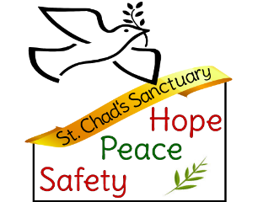

**I was a stranger and you made me welcome**

                                    Matthew 25:35

During this Advent, we would like the children in school to think about the importance of being generous and thinking of other families who may be in need. As part of this we would like families to donate some goods that would be gratefully received by St. Chad’s Sanctuary in Birmingham.

St Chad’s Sanctuary aims to support refugees and asylum seekers in Birmingham through welfare support, English language lessons, childcare and help with essential food, hygiene and clothes. Many families rely on the kindness of the local community and volunteers for these necessities; especially at the time of year.

We are asking the children to donate a few items during the Advent season to support this wonderful charity. Each year group will have a focus for their donations as detailed below but any donations are welcome.

(Donations must be new and sealed.)

We do understand that many of our own families find it financially difficult during the run up to Christmas so please just give what you can.

EYFS- toothpaste

Year 1- toothbrushes

Year 2- shower gel

Year 3- gloves

Year 4- rice/sugar

Year 5- socks

Year 6- shampoo

Thank you so much for your support and generosity.

Yours sincerely



Mrs Cooper

Acting Vice Principal