Draw a Whale
Last week we read the story ‘The Snail and the Whale’ by Julia Donaldson. Can you draw your own whale?
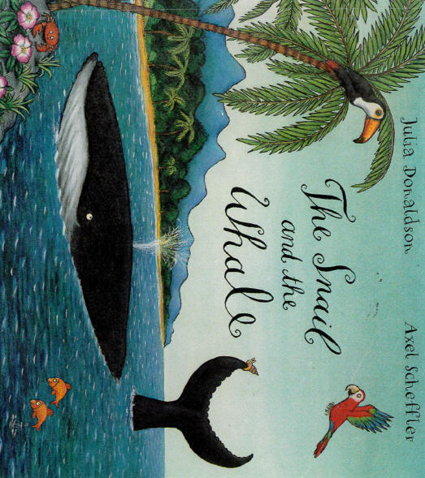
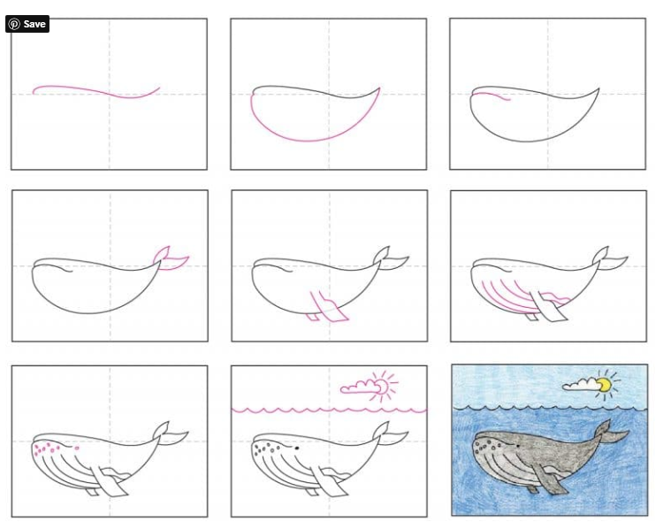
Follow the step by step instructions of how to draw a whale

