L.O. I can make simple inferences.

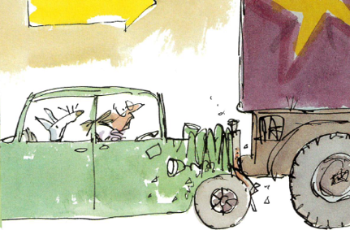

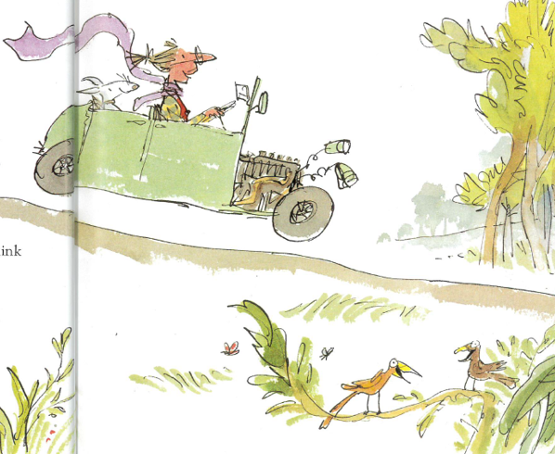

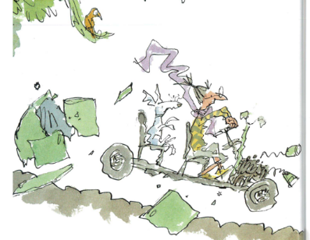

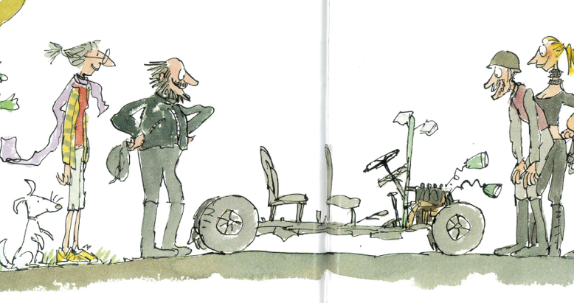

Possible Answers

Oh, where did that lorry come from?

Ooops! I hope my new car is alright.

I wish she would look where she was going.

How did she miss that lorry? It is huge!

I don’t want to die!



This is blissful.

It is lovely out here in the countryside.

The countryside is peaceful.

I can hear birds singing.

This is more like it. Now I am starting to enjoy myself.

The car is falling apart!

This is a very bumpy ride.



This road is very bumpy!

This is fun!

Wow! This vehicle is really cool.

I wish I had one of these new machines.

Why do they all love it? It is broken!

I am glad I am out of that car.



I don’t want to go in that forest. It looks very scary.

I hope there are no scary animals in there.

I can’t believe I have got to go in there. It stinks.

What is that terrible smell?

It looks very scary and dark in there.

Why did the kiss have to go this way?

Who shall I eat first, the horse or the knight?

How dare they sit on my fingers!

Please don’t eat me, scary green dragon.

Wow! Those teeth look terribly sharp.

It’s so high up here. I hope the dragon doesn’t drop me.

I’m so glad I’ve got my kiss back.

Is that a dragon outside?

What a great knight. I knew he would get my kiss back.

I need to stop rushing around all the time.