Use the pictures to write an explanation for how the car turned into the machine that everyone loved.

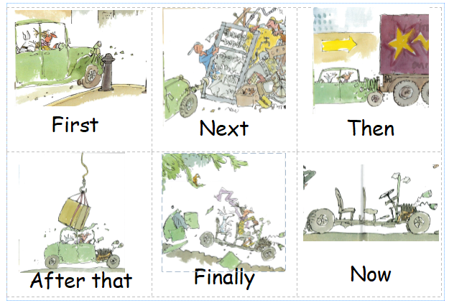
car machine

________________________________________________________________________________________________________________________________________________________________________________________________________________________________________________________________________________________________________________________________________________________________________________________________________________________________________________________________________________________________________________________________________________________________________________________________________________________________________________________________________________________________________________________________________________________________________________________________________________________________________________________________________________________________________________________________________________________________________________________________________________________________________________________________________________________________________________________________________________________________________________________________________________________________________________________________________________________________________________________________________________________________________________________________________________________________________________________________________________________________________________________________________________________________________________________________________________________________________________________________________________________________________________________________________________________________________________________________________________________________________________________________________________________________________________________________________________________________________________________________________________________________________________________________________________________________________________________________________________________________________________________________________________________________________________

