Transition Art
Use the templates attached and create your own “I can’t imagine life without” wheel. Think carefully about everything that you care about and couldn’t be without both inside and outside of school.

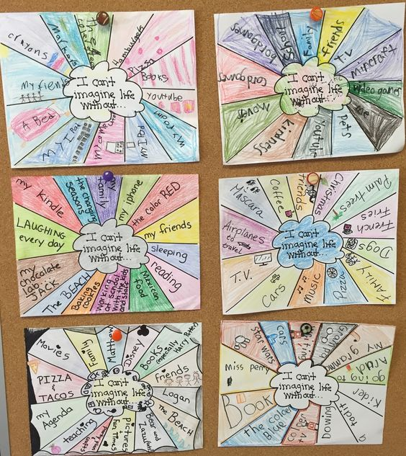

Crystal Balls
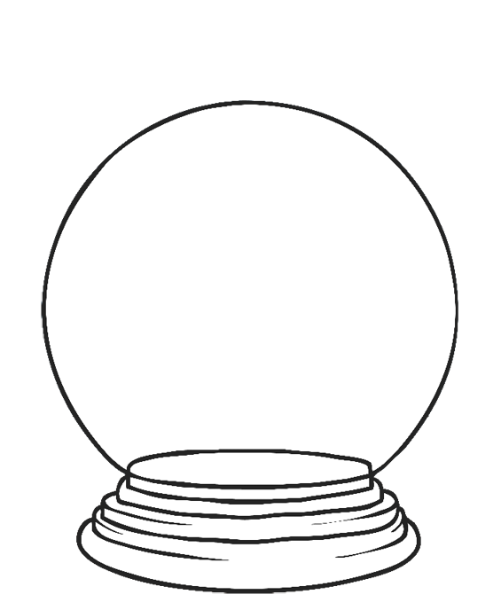
The Task:
Before you start year 5 you are to write one think you predict you will achieve by the end of year 5 and then draw this prediction.

Name clouds
Write your name in a bubble on a piece of paper and decorate.
With other strips of paper (coloured if you have it) write words to describe yourself. A maximum of 6 and stick them so they are hanging off your name cloud.

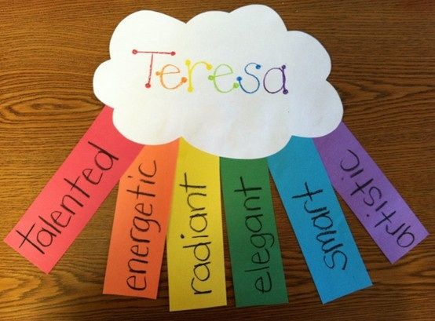

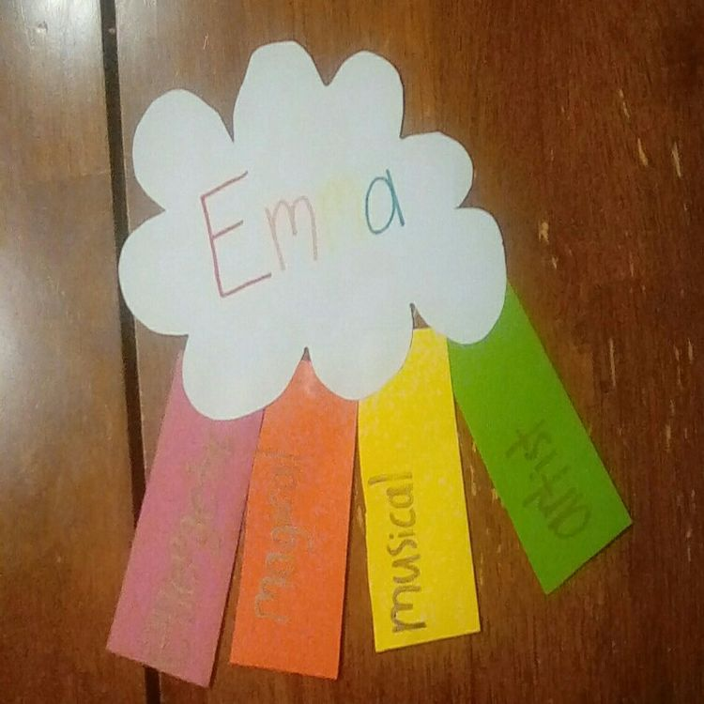
I have completed an all about me Ice Cream stack. You have been given the scoop on Miss Mistry and myself now we want to know everything about you.
Print our or draw the template below and add in some facts about yourself.
Miss Callan
I went to Sacred Heart when I was little and Mrs Elliott was my teacher.
I have 2 children. One boy and one girl.
I would love to go to New York on holiday.

I am Irish
I used to do Irish Dancing
I danced in competitions against people from all over the WORLD.
I decided I wanted to be a teacher when I was 5.
McDonalds is definitely my favourite place to get dinner!
I love chocolate!
My favourite thing ever is being a teacher.

I love spending time with my family

I used to live in Singapore
I am a volunteer at the Children’s Hospital

My favorite dog is a Pug
My favorite sport is swimming
I enjoy watching Formula 1

I have worked at Sacred Heart for 7 years
I love listening to Jazz music

I love to travel

I like Justin Bieber

Miss Mistry

.
.
.
.
.
.
.
.
.
.
.

