Paper fish
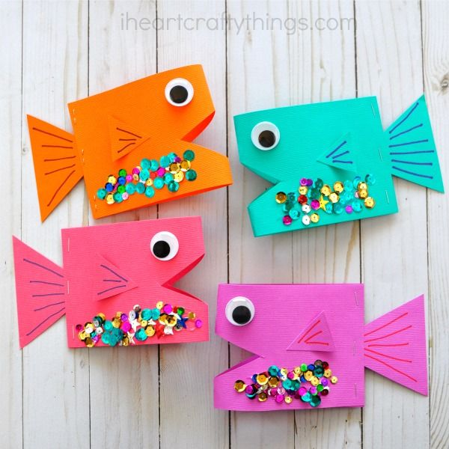
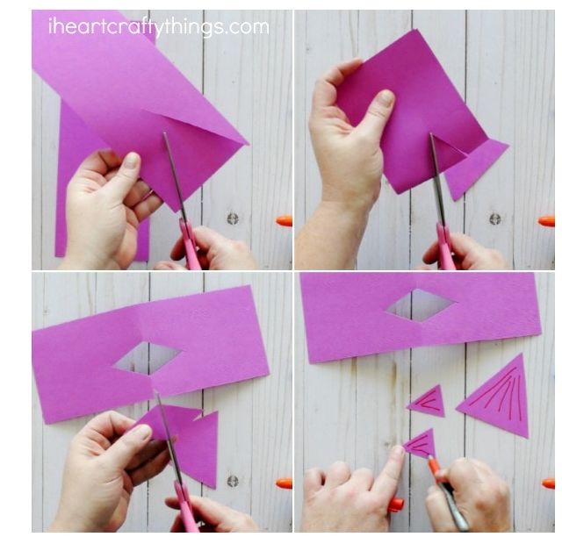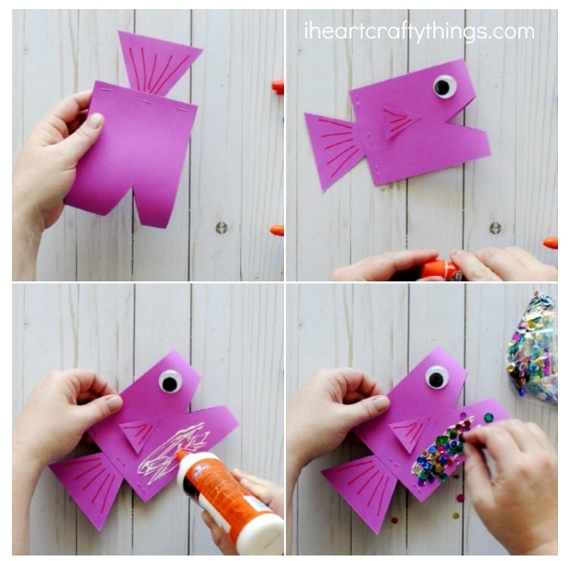
- Get some coloured paper or decorate a piece of paper and cut into a rectangle shape.
- Fold the rectangle in half and cut out a tringle for the mouth at the folded side.
- Use the diamond shape that you have cut out from the mouth to cut in half for the fins.
- Draw a larger triangle for the tail and cut it out.
- Stick the tail and fins onto the folded rectangle and draw an eye on both sides above the mouth.

