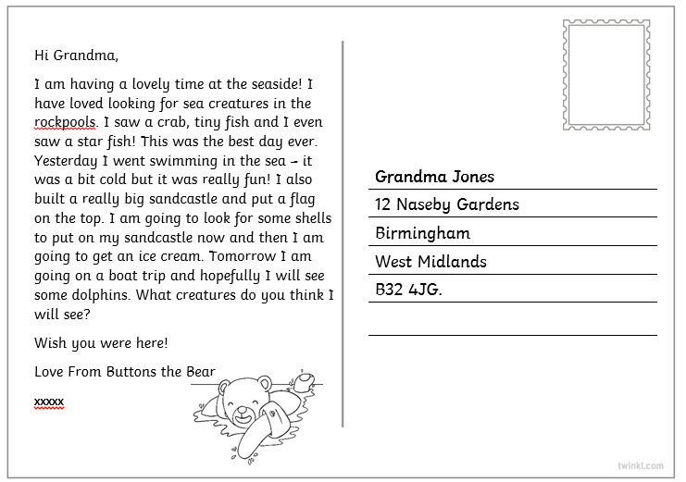
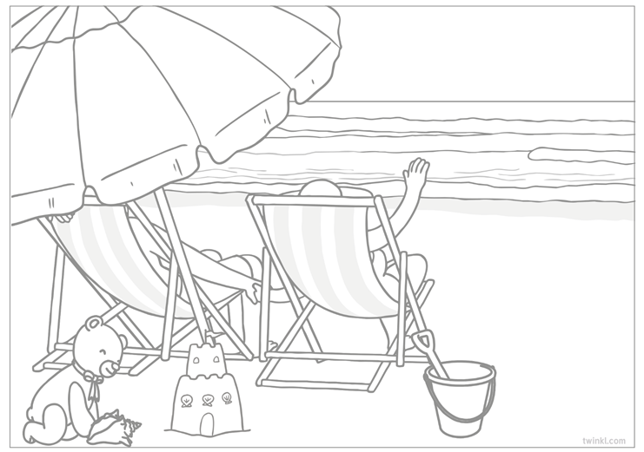
Read the postcard below.
Buttons the Bear’s postcard has got jumbled up. Can you help him to put it back together? Use the postcard layout on page 3 to stick it all together.

Hi Grandma,

Tomorrow I am going on a boat trip and hopefully I will see some dolphins.

Yesterday I went swimming in the sea – it was a bit cold but it was really fun! I also built a really big sandcastle and put a flag on the top. I am going to look for some shells to put on my sandcastle now and then I am going to get an ice cream.

What creatures do you think I will see?
I am having a lovely time at the seaside! I have loved looking for sea creatures in the rockpools. I saw a crab, tiny fish and I even saw a star fish! This was the best day ever.

Wish you were here!

Love From Buttons the Bear xxxx

The postcard from Buttons the Bear has been jumbled up. Look at the structure of a postcard below and put Button’s letter back together again.

Informal greeting

The best bit
What you did
Yesterday
What you’re going to do tomorrow

Question to the reader

Closing sentence
Finishing off

