Tuesday 7th July
LO: To compare the physical and human geographical features of England and France.

Can you make comparisons between the human and physical geographical features of England and France?

Looking at the human features of England and France, identify two similarities and two differences and write in full sentences.

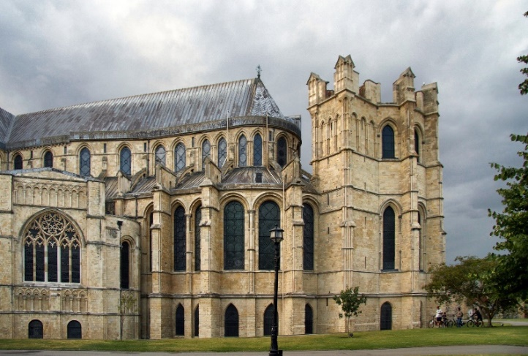
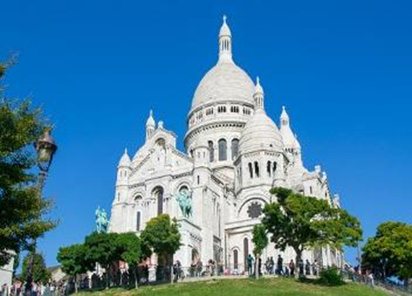
Canterbury Cathedral
Sacre Coeur

Identify two similarities

Identify two differences

Looking at the physical features of England and France, identify two similarities and two differences and write in full sentences.
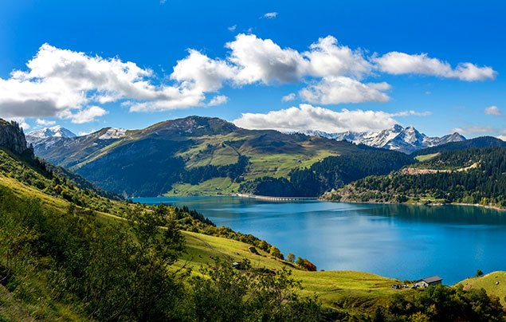
White Cliffs of Dover
French Alps
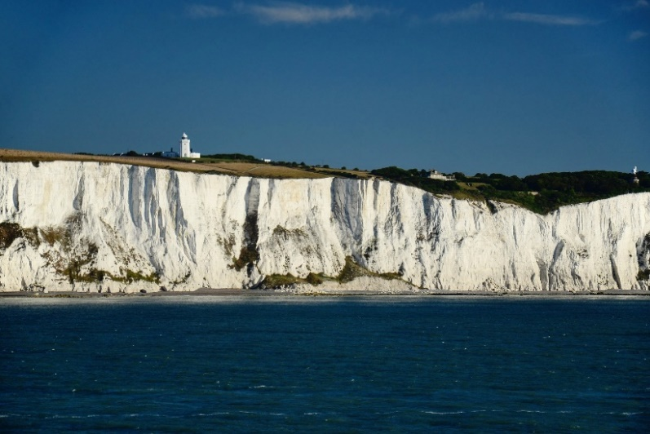

Identify two similarities

Identify two differences

