Year 1 English Activities
WB 13.07.2020
Red words to learn to read and spell this week.
Sister brother father mother friends
Text – Mrs Armitage Queen of the Road
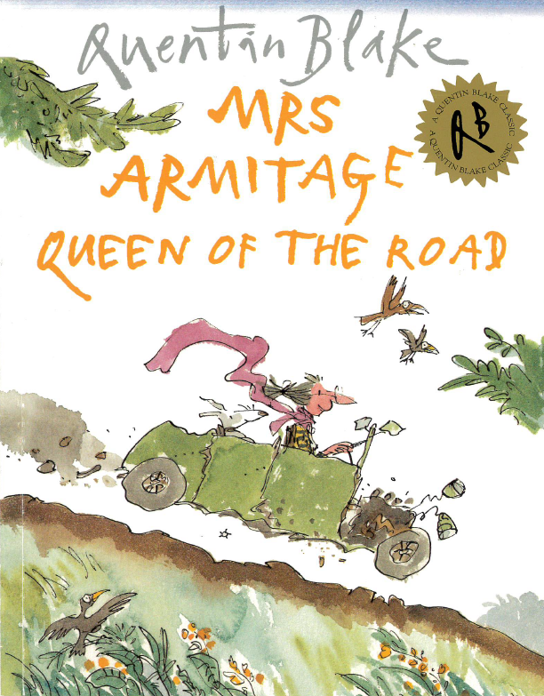
Read the text daily at the beginning of each English lesson.
Monday
After reading the text, look at how Mrs Armitage’s car changed and become the machine everybody loved. Write how this happened using the picture clues and time conjunctions.

Tuesday
Read ‘Mrs Armitage Queen of the Road’
Answer the questions about the text. You can use the text to help answer these questions.
Wednesday
Today you are going to be making simple inferences based on the story. Look at each picture from the story and decide what the characters might be thinking and write them down in the thought bubbles.
Thursday
Read ‘Mrs Armitage Queen of the Road’
Today you will be showing your understanding of the characters and using your imagination too. You need to answer the inference questions remembering to give reasons for why you think it. The final question requires you to use your imagination and decide what she might do next.
Daily reading
In the English folder there is a home reading text for you to read every day to practise your phonics. Read the book to an adult every day.
Mrs Flint’s Group – A Box Full of Light
Mrs Badland’s group – Tag

