Now that you know the story well, it is now time to show your opinion of the story and characters. You need to think about what has happened in the story and give reasons why you think it.
What impression do we get of Mrs Armitage? List words around the picture of Mrs Armitage. (What is Mrs Armitage like?)

Choose 2 words and write in full sentences why you think this.
______________________________________________________________________________________________________________________________________________________________________________________________________________________________________________________________________________________________________________________________________________________________________________

What do you think was Mrs Armitage’s favourite part of her day? Why?
_____________________________________________________________________________________________________________________________________________________________________________________________________________________________________________________________________________________________________________________________________________________________________________________________________________________________________________________________________________________________________________________________________________________________________

What do you think was Mrs Armitage’s worst part of her day? Why?

What do you think was Mrs Armitage’s worst part of her day? Why?
______________________________________________________________________________________________________________________________________________________________________________________________________________________________________________________________________________________________________________________________________________________________________________

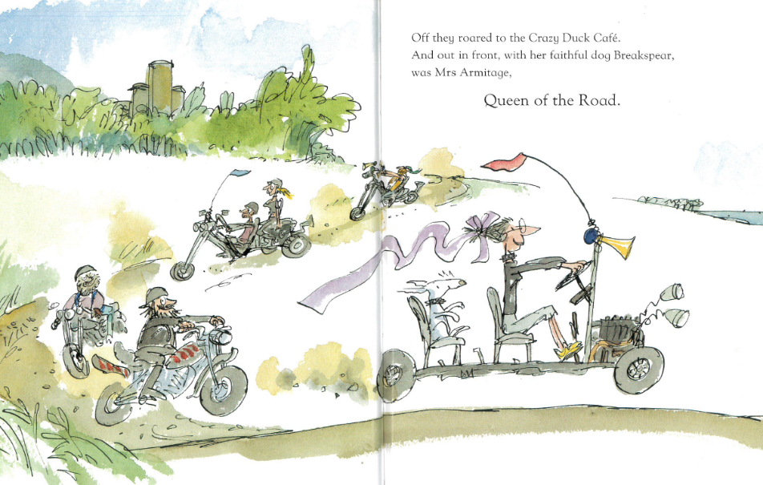

What might Mrs Armitage do next now she is queen of the road?
______________________________________________________________________________________________________________________________________________________________________________________________________________________________________________________________________________________________________________________________________________________________________________

