Sharing Jesus’ Life

The Bible is divided into the Old Testament and the New Testament. The Old Testament has stories that happened before Jesus was born and the New Testament has stories about Jesus and His Disciples.
Activity 1
Look at the images below of stories we have read this year about Jesus’ Life. He changed the lives of many people he met. Look at the images below and list the stories of Jesus’ life.
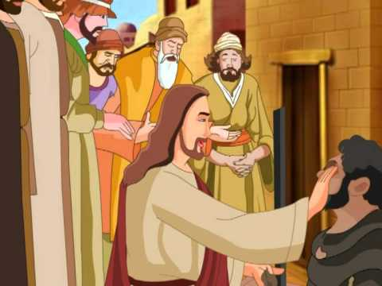
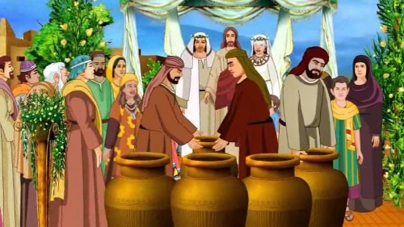
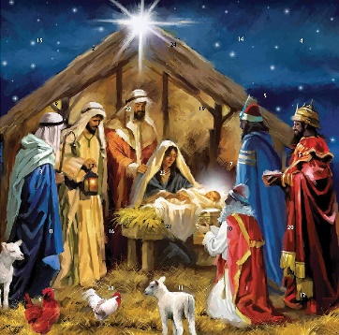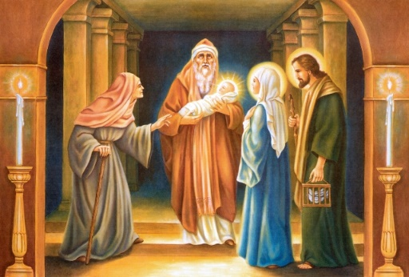
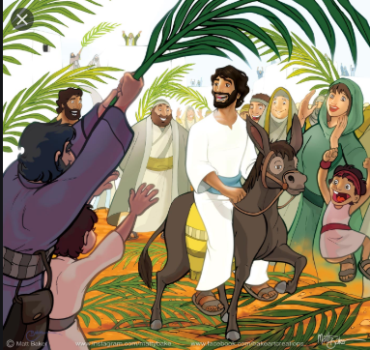
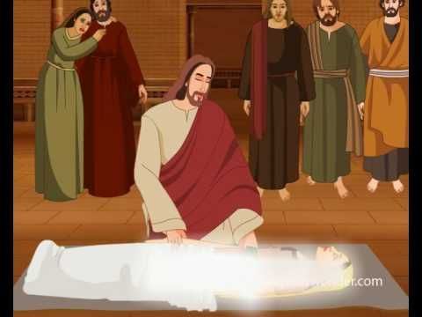

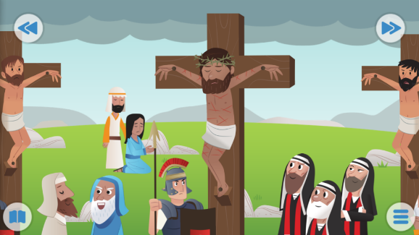
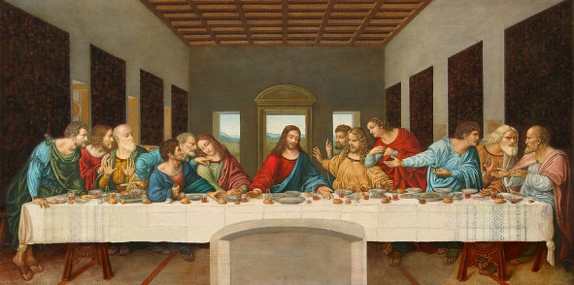

Activity 2
Look again at the pictures from Jesus’ life and complete the ‘favourites’ sheet below.

My favourite miracle story is  ___________________________________  Draw a picture  Why? _______________________  ___________________________  ___________________________  ___________________________  ___________________________ | My favourite healing story is  ___________________________________  Draw a picture  Why? ________________________  ____________________________  ____________________________  ____________________________  ____________________________
I think Jesus’ happiest story is  ___________________________________  Draw a picture  Why? ___________________________  ___________________________  ___________________________  ___________________________  ___________________________ | I think Jesus’ saddest story is  ___________________________________  Draw a picture  Why? ___________________________  ___________________________  ___________________________  ___________________________  ___________________________

