10th January 2020

Dear Parents,

We hope all our children and families had a peaceful and restful Christmas holiday and are looking forward to a new start this year. The Pope’s prayer intention for January is the Promotion of World Peace. We pray that Christians, followers of other religions, and all people of goodwill may promote peace and justice in the world this new year.

**Section 48 Monitoring Visit**

On December 13th, Ben McCardle from the Birmingham Diocese Education Service visited school to assess the school’s provision of RE, Catholic Life and Collective Worship. We are pleased to say that he was extremely impressed and recommended that the school continues to embed all of the wonderful things that are happening at Sacred Heart. During the visit, he spoke to a number of children who spoke so eloquently about what makes our Catholic school so unique and a special place to be. You should be very proud of all of the children as they were wonderful. Please enjoy reading some of the children’s comments that are attached to this letter.

**Weekly Mass**

Thank you so much for all of the parents who have continued to support us through attending our weekly mass in school. Please join us to celebrate on Thursday 17th January at 9.10am when Year 6 will be leading mass.

**Theme day lunch- ‘All Day Breakfast’ Thursday 16th January**

Next week, the school kitchen will be providing a special themed school lunch. All children are encouraged to have a school dinner on this day, including those who normally bring packed lunches. Please speak to the school office if your child does not normally have a school dinner but you would like to pay for them to have one on this day.

**Educational visit payments**

All visits and enrichment opportunities are subsidised by school and parents have been asked for a maximum £5.00 contribution towards costs. We do understand that some families may have financial difficulties ate times so if parents are struggling to contribute towards these visits then they must please speak to Mrs Elliott or Mrs Cooper.

If contributions continue to decrease then unfortunately the number of opportunities provided for the children will have to be reduced as the school budget cannot cover the costs. This would be a terrible shame for the children.

**Communication**

We have had a number of issues since returning regarding permission slips not being returned to school for educational visits. This is resulting in staff having to spend a lot of time sending new letters or phoning parents to acquire permission. From next week, children will receive one letter and then these letters will be placed on parent mail for completion. If permission is not provided then unfortunately children will not be able to go on the trips.

**Gifts from God**

Well done to all those children who brought in their trophies, medals and certificates last week; you have truly shown us all how you have used your God given gifts. Keep them coming!

**Congratulations**

The winning house this week was: Saint John

Please encourage your children to wear their Saint badge with pride.

**Commendations**

Well done to the following children: Bietab Yohannes, Tomass Lusis, Nicole-Raisa Mihai, Skylar Donegal, Chinasa Udekwelu, Meliyah Scott and Kah’vanni Lincoln.

**Presentation award:** Josephine Nkrumah Kutten, Kayla-Rose Decoidiva, Aaron Adhanom, Princela Manu, Charlie-Sue Williams and Nadia Yentumi

**Gospel Virtues**

This half term pupils are growing to be compassionate towards others, near and far, especially the less fortunate; and loving by their just actions and forgiving words.

This week the following children have displayed their wonderful virtues: Isa Hussain, Diarra Mbacke, Jakub Maszota, Solomie Tedros, Kian Gordon and Abigail Adhanom

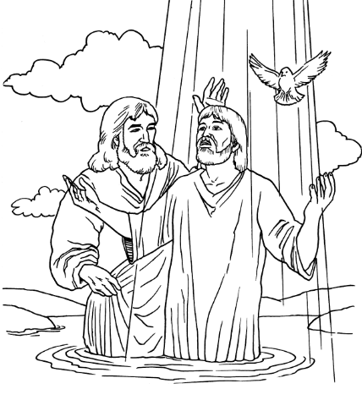  
Regardless of our past, God invites each one of us to make a new start, each and every day. Families who make a new start with God find that they grow closer together and begin to know and share the joy that Jesus brings.

“Lord, open my heart, mind and ears to receive your Word.”

Jesus went to the River Jordan to be baptised by John the Baptist. As soon as Jesus was baptised he came up from the water, and suddenly the heavens opened and he saw the Spirit of God descending like a dove and coming down on him. A voice spoke from heaven saying, “This is my beloved Son and with him I am very pleased.”

*Matthew 3: 13-17*

**Wednesday’s Word is**

**New Start**

*“The newness which God brings into our life is something that gives true joy.”*

Pope Francis

Yours sincerely





Mrs G Elliott

Acting Head of School



Mrs D Cooper

Acting Vice Principal

Mr G M O’Hara

Executive Principal